Report for Lab 1

1. Display a simple polygon mesh as it is illustrated in Fig. 3 (download polygons.wrl)

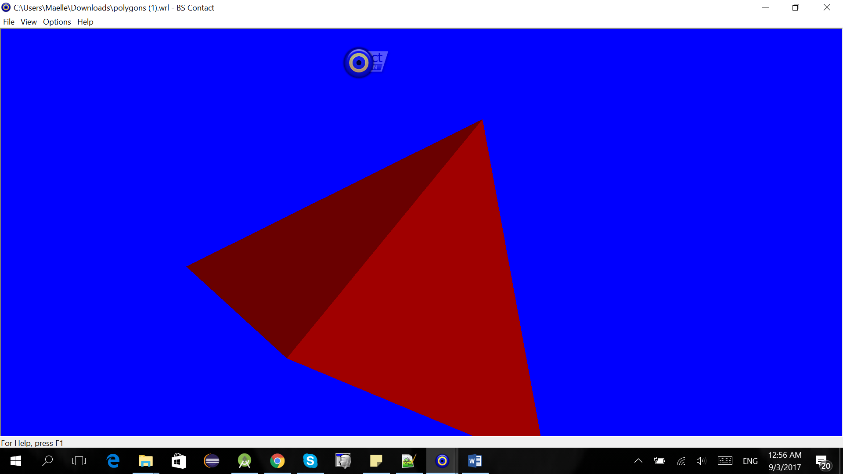

1. Explore different Graphics Modes of the VRML browser (Wireframe, Vertices, Flat). Make sure OpenGL is selected in Settings/Renderer when you right-click at the VRML browser window (See Fig. 1b).

Wireframe:

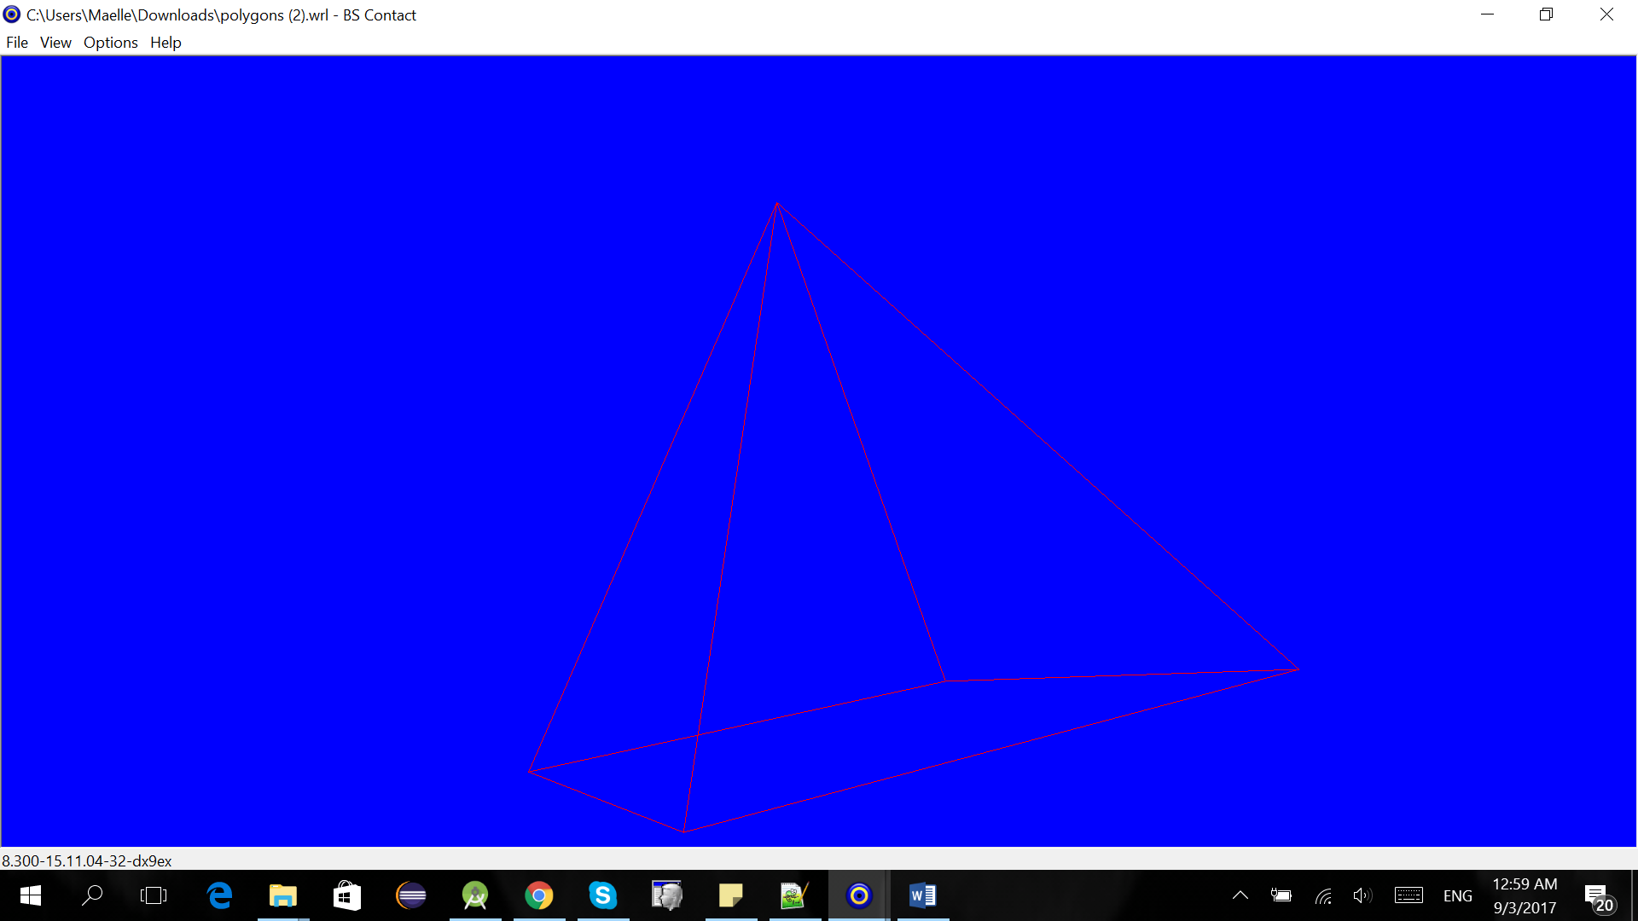

Vertices: Image shows small dots of each vertex that is too small to be seen clearly

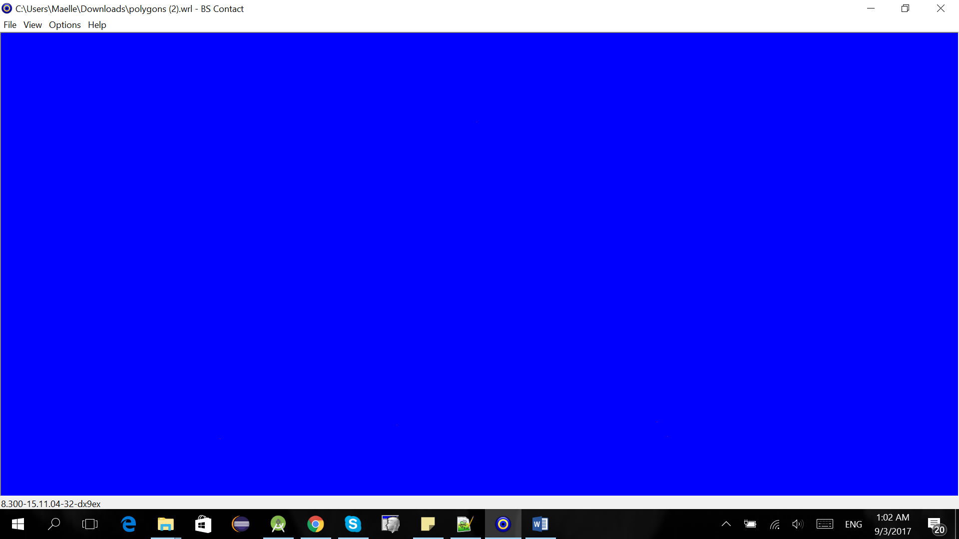

Flat

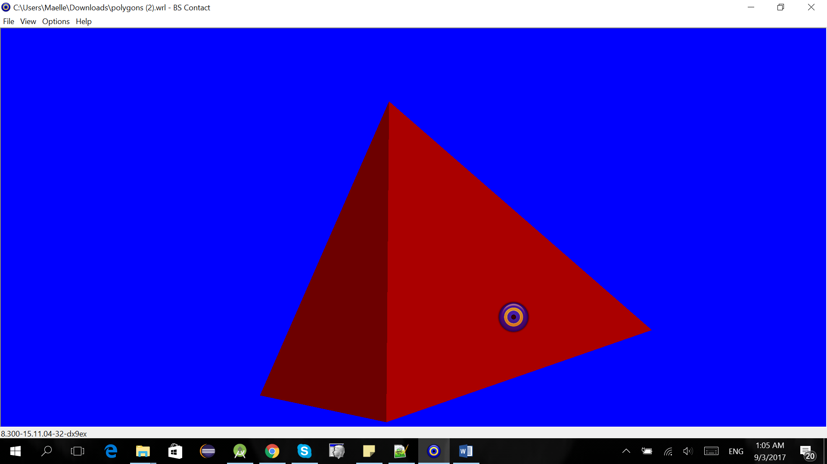

Solid

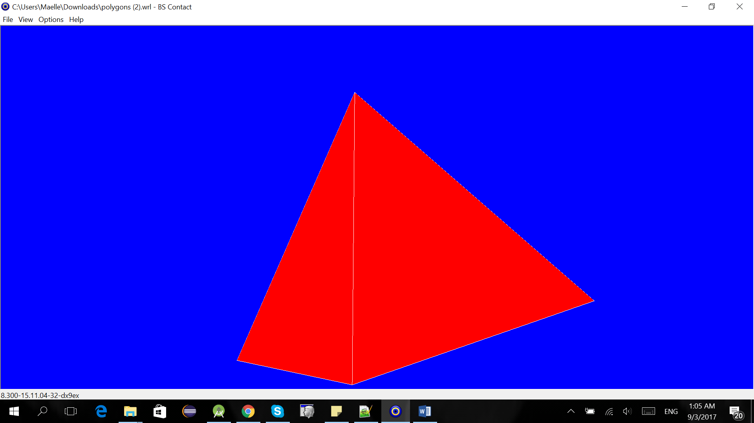

Bounding boxes

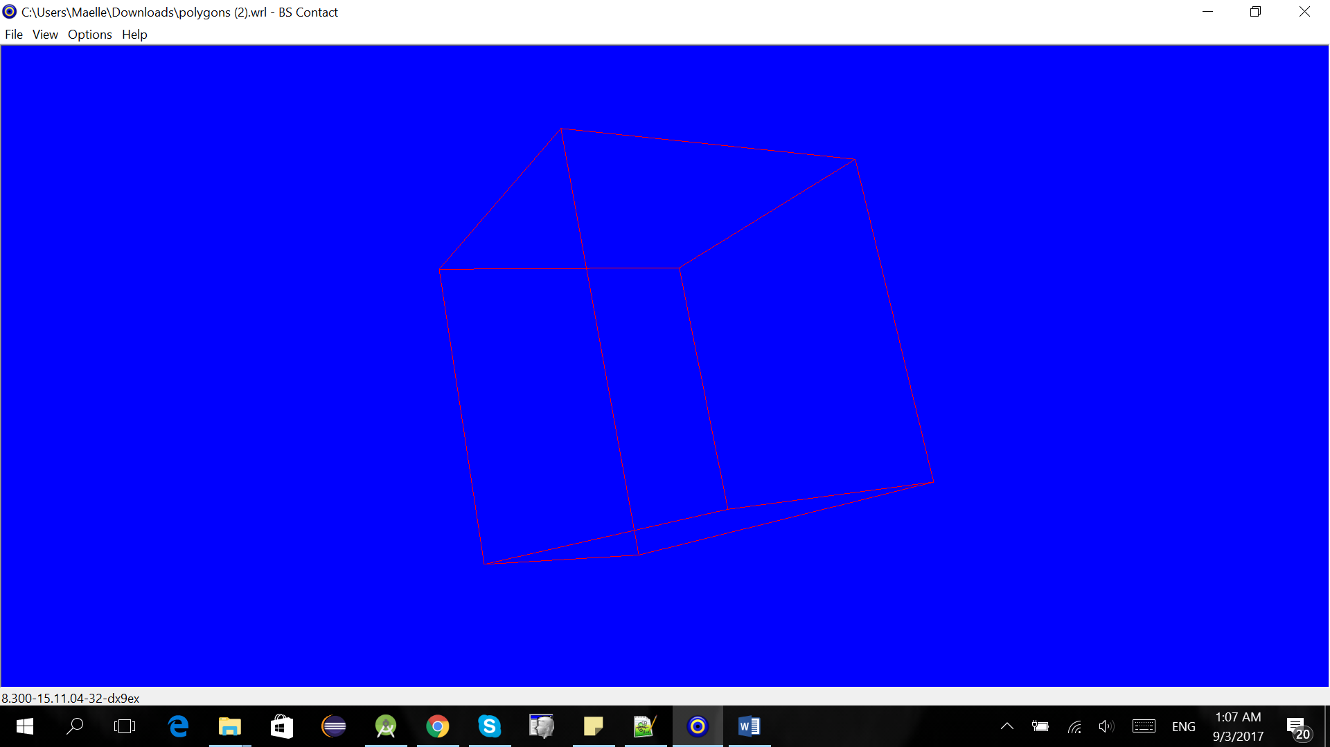

1. Examine how the color of the shape defined in diffuseColor field can be changed. Note that the color values must be real numbers between 0 and 1. See what happens if the color values are less than 0 or greater than 1.

diffuseColor 0.6 0 0.5 #red=0.6, green=0, blue=0.5

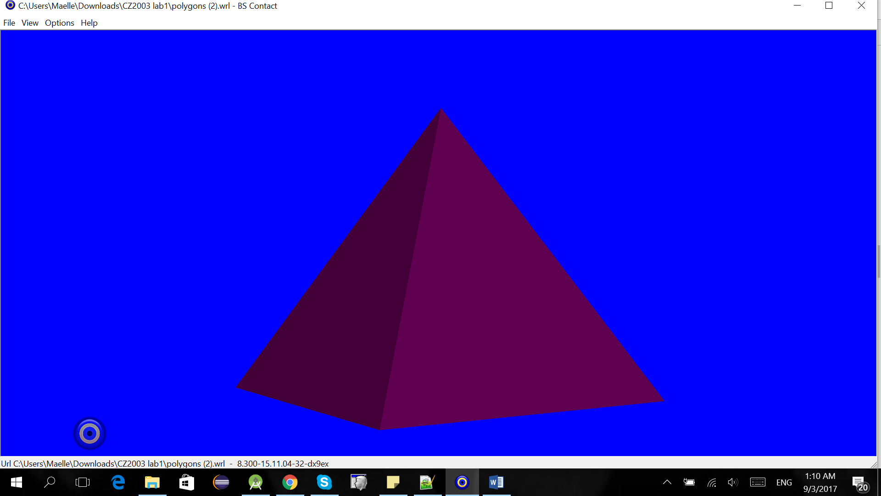

diffuseColor 0 0.5 0.5 #red=0, green=0.5, blue=0.5

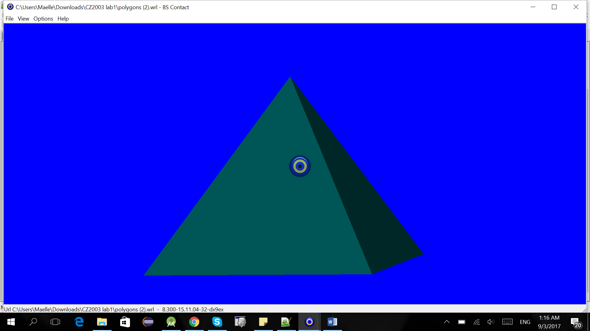

diffuseColor 1 0.1 0.3 #red=1, green=0.1, blue=0.3

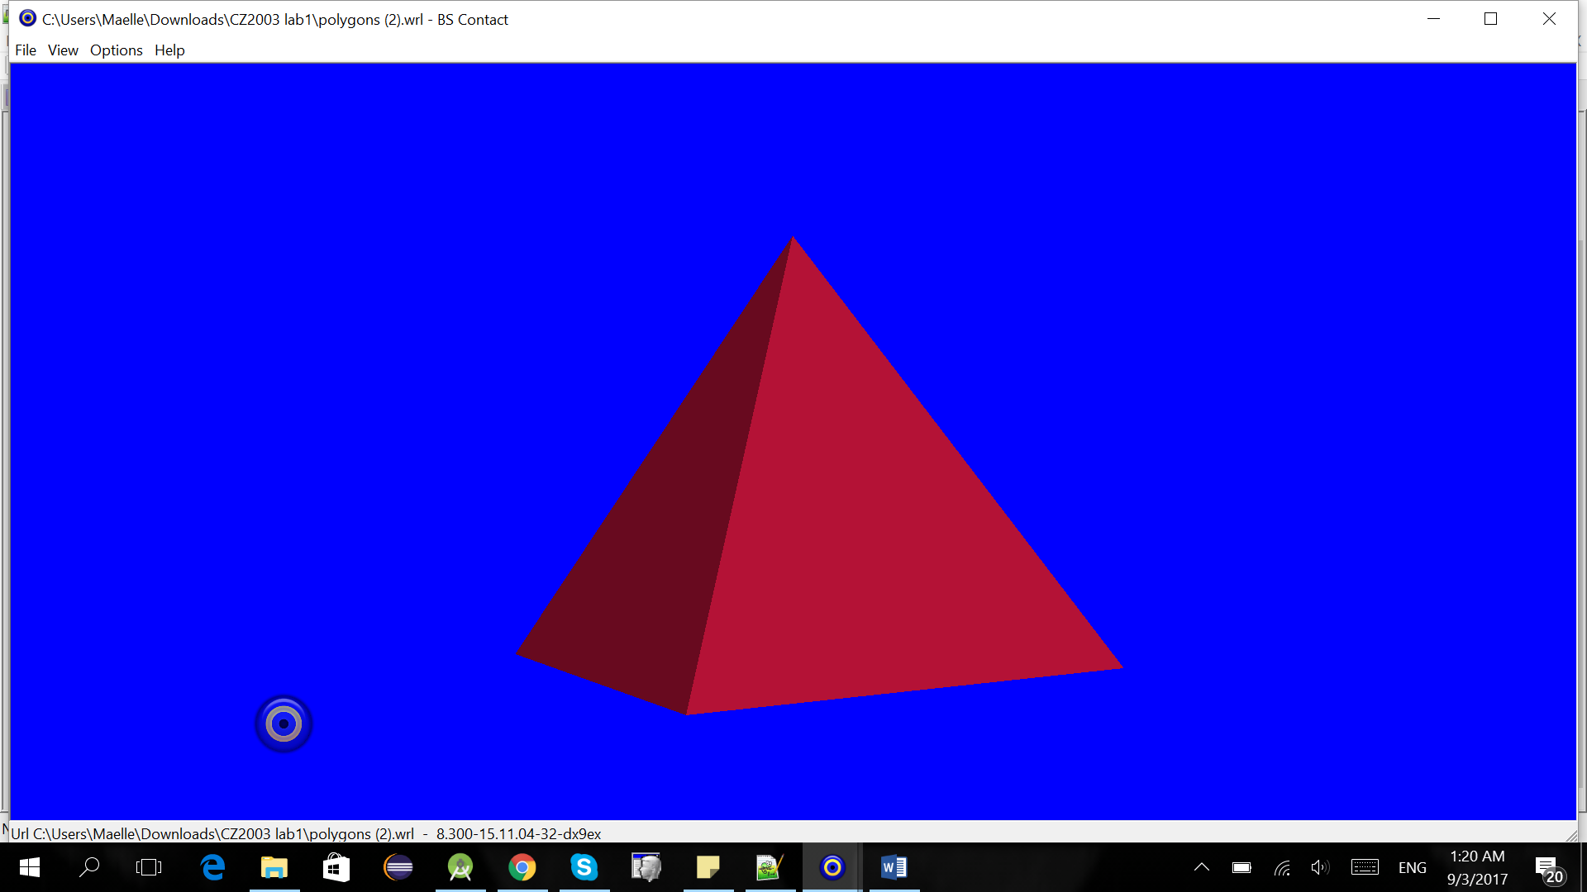

1. Change the displayed polygon mesh (a pyramid) to anything else by adding new vertices and polygons. Make a six-sided polygon (hexagon) and a cube.

Hexagon:

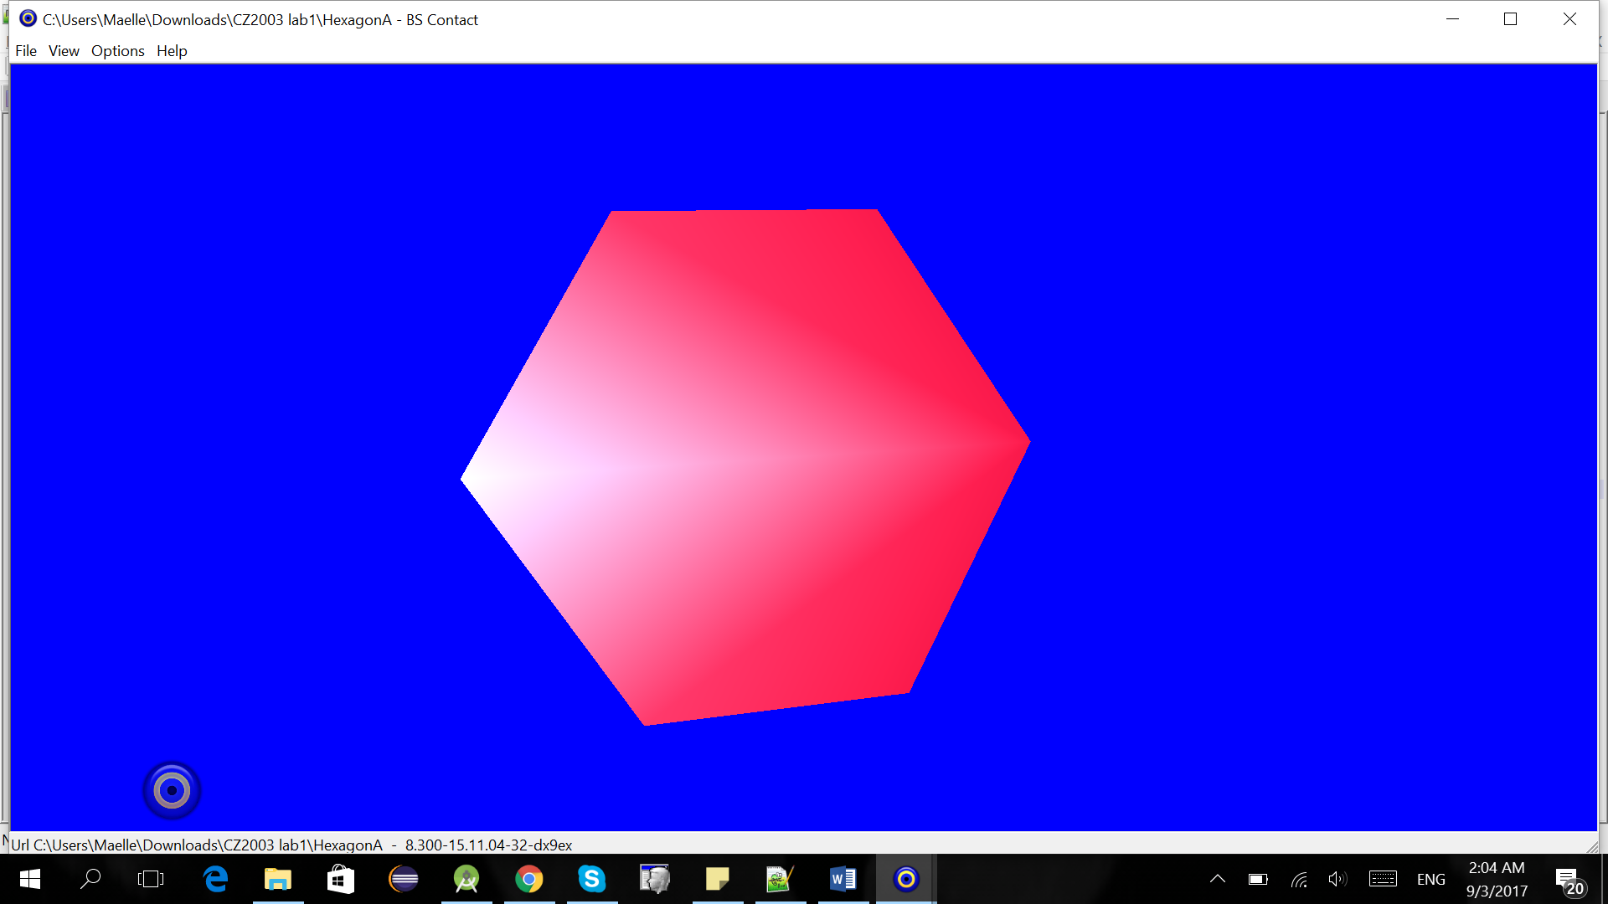

Hexagon with different colours:

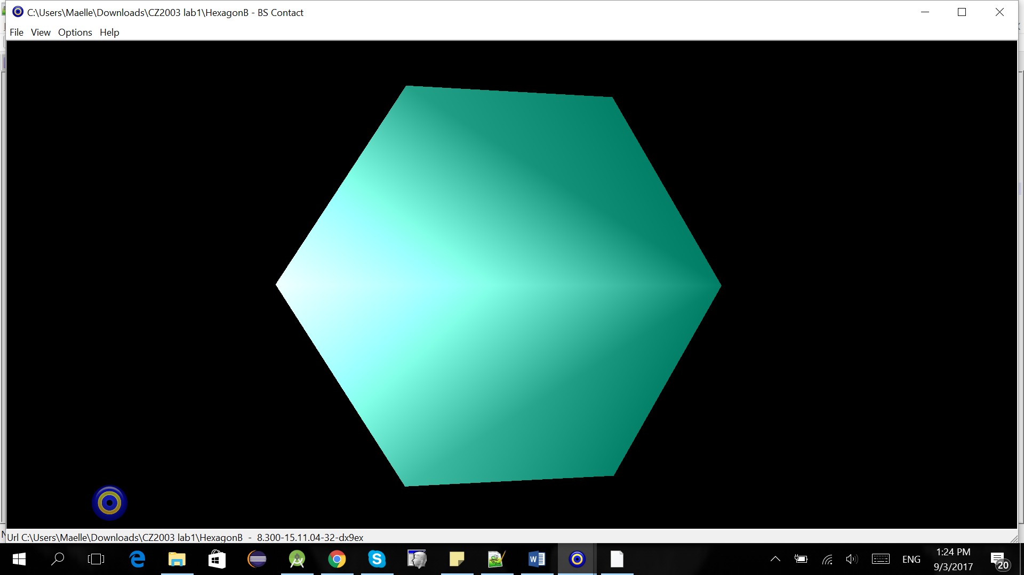

Cube:

